1. FLOWCHART

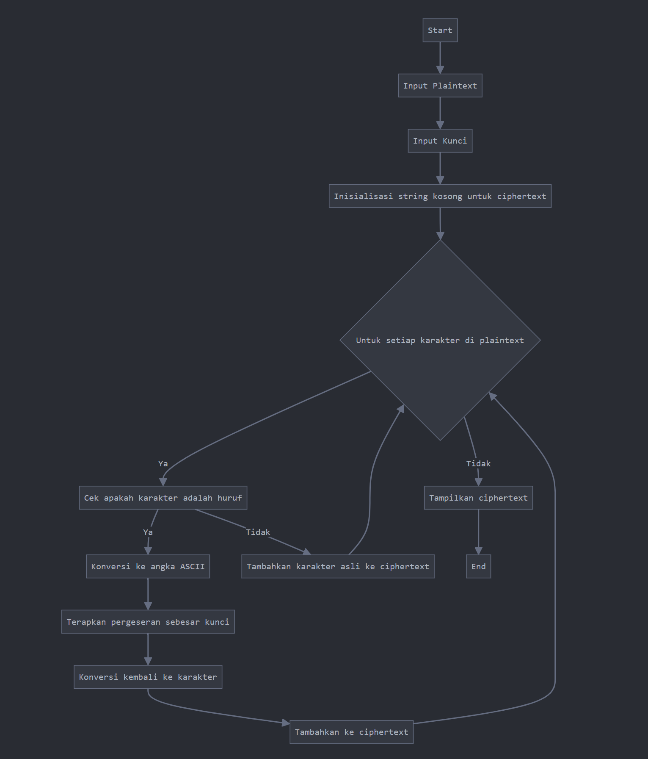

1. Eksekusi Program Python

